Student Laboratory Allocation System using Bipartite Graph and Maximum Matching
Project Report submitted for the partial fulfilment of grade for the course

Data Structures and Algorithms -3 (25CS2103E)
in

A.Y. 2026-2027

Submitted by

Student Name | Student ID
K. Saicharan | 2520030002
Abhidev | 2520030325
Prem | 2520030479

Team Number: 20
Section: 4

Under the guidance of

Mrs. J. Yamini Devi
Assistant Professor , Department of Computer Science Engineering
Hyderabad-500090, Telangana, India.

K L (Deemed to be) University
DEPARTMENT OF COMPUTER SCIENCE ENGINEERING



DECLARATION

The Mini Project Report entitled “Student Laboratory Allocation System using Bipartite Graph and Maximum Matching” is a record of Bonafide work of K. Saicharan – 2520030002, Abhidev – 2520030325, Prem Sai– 2520030479 submitted in partial fulfillment for the award of B. Tech in Computer Science and Engineering to the K L University. The results embodied in this report have not been copied from any other departments/University/Institute.

K. Saicharan – 2520030002
Abhidev – 2520030325
Prem – 2520030479

K L (Deemed to be) University
DEPARTMENT OF COMPUTER SCIENCE ENGINEERING
CERTIFICATE

This is to certify that the mini project based report entitled “Student Laboratory Allocation System using Bipartite Graph and Maximum Matching” is a bonafide work done and submitted by K. Saicharan – 2520030002, Abhidev – 2520030325, Prem – 2520030479 in partial fulfillment of the requirements for the award of the degree of BACHELOR OF TECHNOLOGY in Department of Computer Science Engineering, K L (Deemed to be University), during the academic year 2026-2027.

Signature of the Supervisor

Signature of the HOD Signature of the External Examiner

ACKNOWLEDGEMENT

The success of this project would not have been possible without the timely help and guidance rendered by many people. We wish to express our sincere thanks to all those who have assisted us in one way or the other in completing this project.

Our greatest appreciation goes to our guide, Mrs. J. Yamini Devi , Assistant Professor , Department of Computer Science Engineering, whose tremendous support, encouragement and guidance throughout this project cannot be expressed in words.

We express our gratitude to Dr. P. Venkateshwar Rao (CSE), Head of the Department of Computer Science Engineering, for providing us with adequate facilities, ways and means by which we were able to complete this project-based lab.

We thank all the members of the teaching and non-teaching staff who have assisted us directly or indirectly in the successful completion of this project. Finally, we sincerely thank our parents, friends and classmates for their kind help and cooperation during our work.

K. Saicharan – 2520030002
Abhidev – 2520030325
Prem – 2520030479

TABLE OF CONTENTS

S.No. | Contents | Page no.
1. | Abstract | 6
2. | Introduction | 7
3. | Literature survey | 7
4. | Problem Statement and Objectives | 9
5. | Hardware and Software requirements | 9
6. | Implementation | 10
7. | Results & Discussion | 16
8. | Conclusion & Future Scope | 20
9. | References | 22

1.ABSTRACT
Allocating limited laboratory seats among a large number of students is a common problem in universities. When every student lists several preferred laboratories and every laboratory has a fixed capacity, manual allocation is slow, error-prone and often leaves seats unused while students are turned away. This project presents a Student Laboratory Allocation System, developed in Java, that solves the problem using graph algorithms from the Data Structures and Algorithms-3 course. Student preferences are modelled as a bipartite graph: one set of vertices represents students and the other represents individual laboratory seats, with an edge wherever a student has listed that laboratory among five ranked choices. A maximum matching is then computed with Kuhn's augmenting-path algorithm (depth-first search), so that the largest possible number of students receive a seat and no seat is given to more than one student. The system reads a dataset of 100 students and eight laboratories with a total of 70 seats, and provides a menu-driven console interface to view the preference graph, run the matching, and generate allocation, laboratory-wise and preference-rank reports. On the supplied dataset the system allocated 70 of 100 students, filling every seat in all eight laboratories (the theoretical maximum). Of the allocated students, 48 received their first choice and 59 received one of their top two choices. The project demonstrates how graph modelling and matching algorithms can turn a resource-allocation problem into a fast, fair and verifiable procedure.

Team Members:
- K. Saicharan 2520030002
- Abhidev 2520030325
- Prem 2520030479
- INTRODUCTION
2.1 Background
Every semester, departments must decide which student works in which laboratory. Laboratories such as the AI Lab, DBMS Lab, Java Lab, Python Lab, Computer Networks Lab, Operating Systems Lab, Data Science Lab and Cyber Security Lab have a limited number of seats, while student interest is uneven: in our dataset, 18 students rank the Java Lab first but only 6 rank the Cyber Security Lab first. A simple first-come-first-served list can fill popular labs quickly and, more importantly, can block a later student from a seat that could have been freed by moving an earlier student to another acceptable lab.
2.2 Motivation
Allocation of this kind is a classic application of the maximum bipartite matching problem studied in Data Structures and Algorithms. It lets us reason about the problem precisely: instead of ad-hoc rules, we ask for the largest set of student–seat pairs such that every student gets at most one seat and every seat is given to at most one student. This project applies that idea to a realistic, data-driven scenario and shows how graph representation, depth-first search and recursion work together in a working application.
2.3 What the project does
The Student Laboratory Allocation System loads student preferences and laboratory capacities from a CSV file, builds a bipartite preference graph, expands every laboratory into individual seat vertices, and runs Kuhn's algorithm to obtain a maximum matching. The user interacts with the system through a console menu with nine options, which display the graph, run the matching and print the allocation, laboratory-wise, preference-rank and summary reports.
2.4 Organisation of the report
Section 3 reviews related work on bipartite matching and allocation problems. Section 4 states the problem and objectives. Section 5 lists hardware and software requirements. Section 6 describes the implementation with the main source code modules. Section 7 presents the results with screenshots of the running application and discusses them. Section 8 concludes the report and outlines future scope, and Section 9 lists the references.
- LITERATURE SURVEY
The following existing works and learning resources on bipartite matching and allocation problems were studied before designing this project. Their URLs are listed in the References section.
1. Kuhn's Algorithm for Maximum Bipartite Matching (CP-Algorithms). This article explains how a maximum matching is found by repeatedly searching for augmenting paths with depth-first or breadth-first traversal, starting from an empty matching. It builds on Berge's lemma, which states that a matching is maximum exactly when no augmenting path exists. This is the core technique used in our project: our dfsMatch method is a direct implementation of the same idea. The article also discusses the running time of the method.
2. Maximum Bipartite Matching – job applicants and jobs (GeeksforGeeks). This tutorial models a job-assignment problem in which each applicant is interested in some jobs and each job can accept only one applicant. It solves the problem by trying every applicant and using DFS to re-assign a previously matched applicant to another job whenever needed, and also notes the link with the Ford–Fulkerson maximum-flow algorithm. Our project follows the same applicant-to-opening model, with students in place of applicants and laboratory seats in place of jobs.
3. What is the maximum bipartite matching problem? (Educative). This explanation introduces matching through a processor–task example and shows how matching as many entities as possible gives the best utilisation of resources. It lists practical uses such as assigning jobs to interested people. It helped us frame the laboratory-allocation problem as a resource-utilisation problem rather than a simple sorting problem.
4. Applying matching algorithms to real allocation problems (Denis Sudak). This article series points out that many real allocation problems, such as assigning workers to jobs or students to courses, reduce to maximum bipartite matching, and then extends the basic example towards more realistic scenarios using flow networks. It motivated our decision to treat laboratory capacities by creating one vertex per available seat, which is a standard way of handling capacity in a matching model.
5. Bipartite Matching lecture notes (University of British Columbia, CPSC 490). These notes describe the applicants-and-openings problem and show how it can be reduced to a maximum-flow problem by adding a source and a sink with unit-capacity edges. They also present an implementation that stores the matching in arrays. They helped us understand the equivalence between maximum matching and maximum flow, which is the basis for several of the future-scope improvements.
6. CS 341 Algorithms, Lecture 15 – Bipartite Matching (University of Waterloo). The lecture defines the bipartite matching problem, perfect matchings and the job-assignment application, and proves that a matching is maximum if and only if there is no augmenting path. It then derives a simple local-search algorithm that grows the matching one augmenting path at a time. This proof gives the correctness argument for the algorithm used in our system.
7. Matchings in Bipartite Graphs, Applied Combinatorics (Runestone Academy). This book section studies the assignment of workers to jobs so that each worker has at most one job and each job at most one worker, and shows how a maximum flow in an associated network gives a maximum matching. It also discusses when a complete assignment is impossible. This is relevant to our dataset, where the 100 students exceed the 70 seats and some students necessarily remain unallocated.
8. Bipartite Matching and the Hungarian Method (Pennsylvania State University notes). These notes cover maximum-cardinality matching and the Hungarian (Kuhn–Munkres) algorithm for maximum-weight matching in weighted bipartite graphs. Weighted matching can be used when preferences carry different weights, so that the allocation is not only maximum in size but also best with respect to preference ranks. We identify this as the main direction for future improvement of our system.
- Problem Statement and Objectives
Problem Statement: To allocate a limited number of laboratory seats among students according to their ranked preferences so that the maximum possible number of students receive a seat.
Problem Description: Each of the 100 students ranks five of the eight laboratories, while the laboratories together offer only 70 seats; the allocation must ensure that no student receives more than one seat and no seat is given to more than one student.
Objectives:
The project was initiated to replace manual, first-come-first-served seat allocation with a systematic procedure based on graph theory. The objectives are:
1. To represent student preferences and laboratory capacities as a bipartite graph using adjacency lists.
2. To convert each laboratory capacity into individual seat vertices so that capacity limits are respected automatically.
3. To compute a maximum matching between students and seats using Kuhn's augmenting-path (DFS) algorithm.
4. To read student and laboratory data from a CSV file instead of hard-coding it.
5. To generate allocation, laboratory-wise, preference-rank and summary reports through a menu-driven interface.
6. To evaluate how well the allocation satisfies student preferences (first-choice, second-choice, etc.).
- HARDWARE AND SOFTWARE REQUIREMENTS
Hardware Requirements:
• Processor: Intel Core i5 (or equivalent) or higher
• RAM: 4 GB minimum (8 GB recommended)
• Storage: At least 500 MB of free disk space
• Display and input: Standard monitor, keyboard and mouse
Software Requirements:
• Operating system: Windows 10/11, Linux or macOS
• Programming language: Java (JDK 8 or later); the sample output in this report was reproduced on OpenJDK 21
• Editor / IDE: VS Code, IntelliJ IDEA, Eclipse or any text editor
• Tools: javac and java command-line tools, terminal / command prompt
• Data: student_lab_allocation_dataset_one_row_per_student.csv (100 students, 8 laboratories)
- IMPLEMENTATION
6.1 System design
The program is organised into five Java classes. Student and Laboratory are simple data classes; DataReader loads the CSV file; Graph builds the bipartite graphs and implements the matching algorithm and reports; and Main provides the menu-driven user interface.
Class | Responsibility
Student.java | Stores student ID, name, department, year and five ranked laboratory preferences
Laboratory.java | Stores laboratory ID, name and seat capacity
DataReader.java | Reads students (one row each) and laboratory capacities (from the first data row) from the CSV file
Graph.java | Builds student-to-preference and student-to-seat graphs; runs maximum matching; prints reports
Main.java | Console menu (9 options) that drives the whole system

6.2 Algorithm
1. Read the 100 student rows and the capacity of each of the 8 laboratories from the CSV file.
2. Create one vertex per student. For every laboratory with capacity c, create c seat vertices named LID-Seat1 … LID-Seatc (70 seats in total).
3. For each student, add an edge to every seat of each of the five preferred laboratories, listed in preference order (4,412 edges for this dataset).
4. For each student in turn, run dfsMatch: try each seat that has not been visited; if the seat is free, or the student currently holding it can be moved to another seat (recursive call), assign the seat to this student.
5. Report the matching: the allocation table, laboratory-wise usage, preference rank of each student, and an overall summary.
Kuhn's algorithm runs in O(V · E) time, where V is the number of students and E the number of student–seat edges. The matching it produces is guaranteed to have the maximum possible size, because the search only stops when no augmenting path remains.
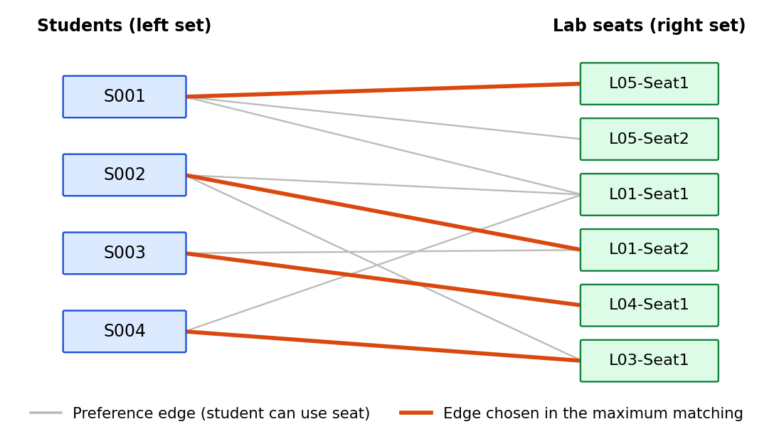
Figure 1: Illustrative bipartite model – students on the left, laboratory seats on the right; highlighted edges form a matching
6.3 Module 1 – Data model and data loading (Student, Laboratory, DataReader)
public class Student {
String studentId;
String studentName;
String department;
int year;

String preference1;
String preference2;
String preference3;
String preference4;
String preference5;

public Student(String studentId, String studentName, String department, int year,
String preference1, String preference2, String preference3,
String preference4, String preference5) {

this.studentId = studentId;
this.studentName = studentName;
this.department = department;
this.year = year;

this.preference1 = preference1;
this.preference2 = preference2;
this.preference3 = preference3;
this.preference4 = preference4;
this.preference5 = preference5;
}
}

public class Laboratory {

String labId;
String labName;
int capacity;

public Laboratory(String labId, String labName, int capacity) {
this.labId = labId;
this.labName = labName;
this.capacity = capacity;
}
}

public static ArrayList<Student> readStudents(String filePath) {

ArrayList<Student> students = new ArrayList<>();

try {
BufferedReader br = new BufferedReader(new FileReader(filePath));

// Skip header
br.readLine();

String line;

while ((line = br.readLine()) != null) {

String[] data = line.split(",");

Student student = new Student(
data[0], // Student ID
data[1], // Student Name
data[2], // Department
Integer.parseInt(data[3]), // Year
data[4], // Preference 1
data[5], // Preference 2
data[6], // Preference 3
data[7], // Preference 4
data[8] // Preference 5
);

students.add(student);
}

br.close();

} catch (Exception e) {
System.out.println("Error reading students.");
e.printStackTrace();
}

return students;
}
6.4 Module 2 – Graph construction (Graph.java)
public class Graph {
LinkedHashMap<String, ArrayList<String>> adjacencyList;
LinkedHashMap<String, ArrayList<String>> seatGraph;

public Graph() {
adjacencyList = new LinkedHashMap<>();
seatGraph = new LinkedHashMap<>();
}
// ...
}

public void addStudent(Student student) {

ArrayList<String> preferences = new ArrayList<>();

preferences.add(student.preference1);
preferences.add(student.preference2);
preferences.add(student.preference3);
preferences.add(student.preference4);
preferences.add(student.preference5);

adjacencyList.put(student.studentId, preferences);
}

public void connectStudentsToSeats(ArrayList<Laboratory> laboratories) {

for (String studentId : adjacencyList.keySet()) {

ArrayList<String> preferences = adjacencyList.get(studentId);

ArrayList<String> seats = new ArrayList<>();

for (String preference : preferences) {

for (Laboratory lab : laboratories) {

if (preference.equals(lab.labName)) {

for (int i = 1; i <= lab.capacity; i++) {

seats.add(lab.labId + "-Seat" + i);
}
}
}
}

seatGraph.put(studentId, seats);
}
}
6.5 Module 3 – Maximum matching using Kuhn's algorithm (Graph.java)
public boolean dfsMatch(String studentId,
Set<String> visited,
Map<String, String> matchSeatToStudent) {

ArrayList<String> seats = seatGraph.get(studentId);

for (String seat : seats) {

if (!visited.contains(seat)) {

visited.add(seat);

if (!matchSeatToStudent.containsKey(seat) ||
dfsMatch(matchSeatToStudent.get(seat),
visited,
matchSeatToStudent)) {

matchSeatToStudent.put(seat, studentId);

return true;
}
}
}

return false;
}

public Map<String, String> maximumMatching(ArrayList<Student> students) {

Map<String, String> matchSeatToStudent = new HashMap<>();

for (Student student : students) {

Set<String> visited = new HashSet<>();

dfsMatch(
student.studentId,
visited,
matchSeatToStudent
);
}

return matchSeatToStudent;
}
6.6 Module 4 – Reports and menu-driven interface (Graph.java, Main.java)
public void displayLabReport(
Map<String, String> matchSeatToStudent,
ArrayList<Laboratory> laboratories) {

System.out.println("\n========== LABORATORY-WISE REPORT ==========");

System.out.printf("%-25s %-10s %-10s%n",
"Laboratory", "Allocated", "Capacity");

System.out.println("-----------------------------------------------");

for (Laboratory lab : laboratories) {

int allocated = 0;

for (String seat : matchSeatToStudent.keySet()) {

if (seat.startsWith(lab.labId + "-")) {
allocated++;
}
}

System.out.printf("%-25s %-10d %-10d%n",
lab.labName,
allocated,
lab.capacity);
}
}

public static void main(String[] args) {

String filePath =
"../data/student_lab_allocation_dataset_one_row_per_student.csv";

ArrayList<Student> students =
DataReader.readStudents(filePath);

ArrayList<Laboratory> laboratories =
DataReader.readLaboratories(filePath);

Graph graph = new Graph();

for (Student student : students) {
graph.addStudent(student);
}

graph.createLabSeats(laboratories);
graph.connectStudentsToSeats(laboratories);

Map<String, String> matching = null;

Scanner scanner = new Scanner(System.in);

int choice;

// do { ... print menu (options 1-9) ...
// switch (choice) { ... } } while (choice != 9);

case 4:
matching = graph.maximumMatching(students);
System.out.println("\nMaximum matching completed.");
System.out.println("Total Allocated Students: " + matching.size());
break;
}
}
- RESULTS & DISCUSSION
The program was compiled and run on the supplied dataset of 100 students. The menu options were executed one by one; the screenshots below show the actual console output (long listings are shortened with “...”).
7.1 Application screens
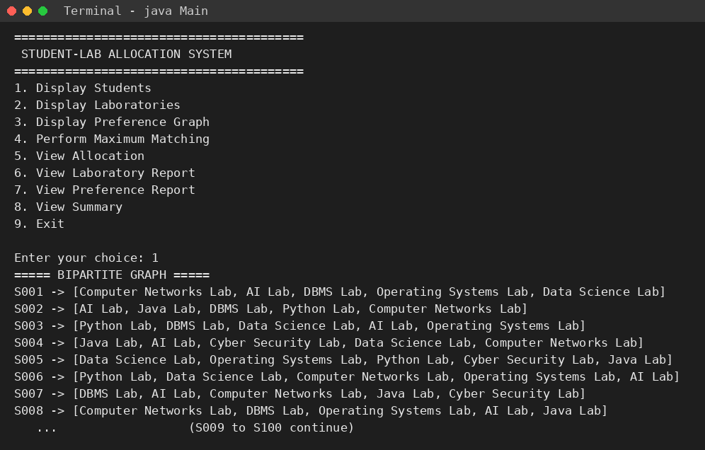
Figure 2: Main menu and the student–laboratory preference graph (option 1)
The menu lists nine options. Option 1 prints the bipartite preference graph, where each student ID (S001–S100) is followed by his or her five preferred laboratories in rank order.
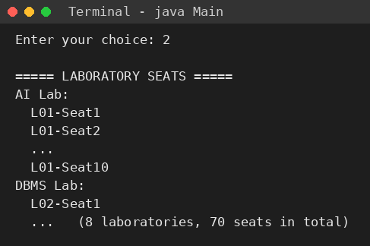
Figure 3: Laboratory seats created from capacities (option 2)
Each laboratory is expanded into individual seat vertices such as L01-Seat1 … L01-Seat10. The eight laboratories give 70 seats in total.
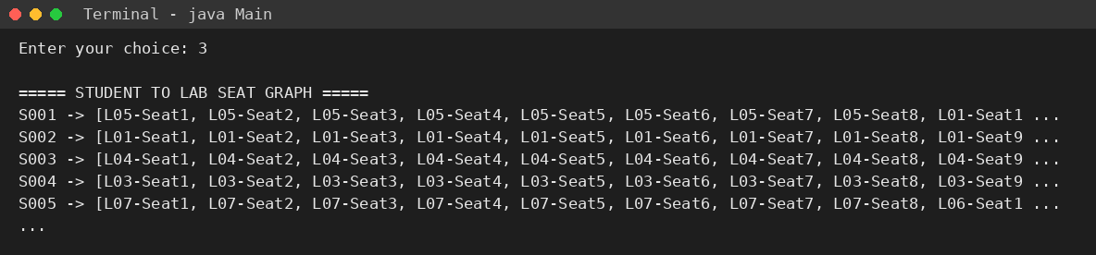
Figure 4: Student-to-seat graph (option 3)
Every student is connected to all seats of his or her five preferred laboratories, in preference order. This graph is the input to the matching algorithm.
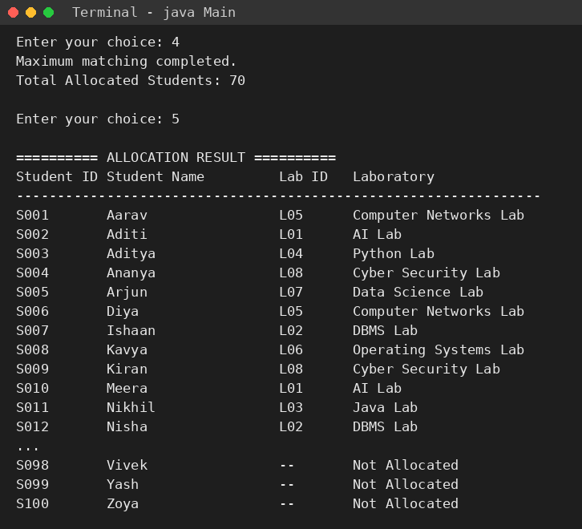
Figure 5: Maximum matching and allocation result (options 4 and 5)
Running the matching allocates 70 students. The allocation table shows the laboratory assigned to each student; students S071–S100 are shown as “Not Allocated” because all seats are already taken.
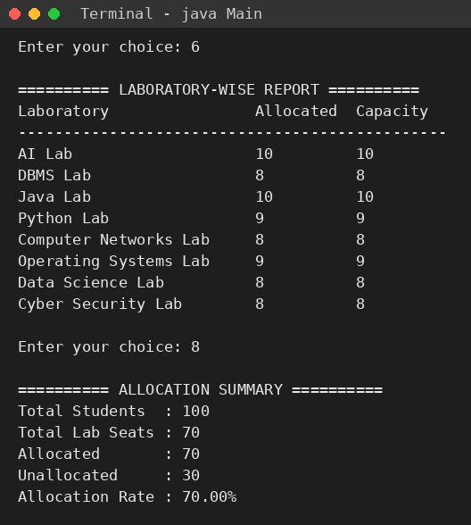
Figure 6: Laboratory-wise report and allocation summary (options 6 and 8)
Every laboratory is filled exactly to capacity (for example AI Lab 10/10, Python Lab 9/9). The summary reports 100 students, 70 seats, 70 allocated, 30 unallocated and an allocation rate of 70.00%.
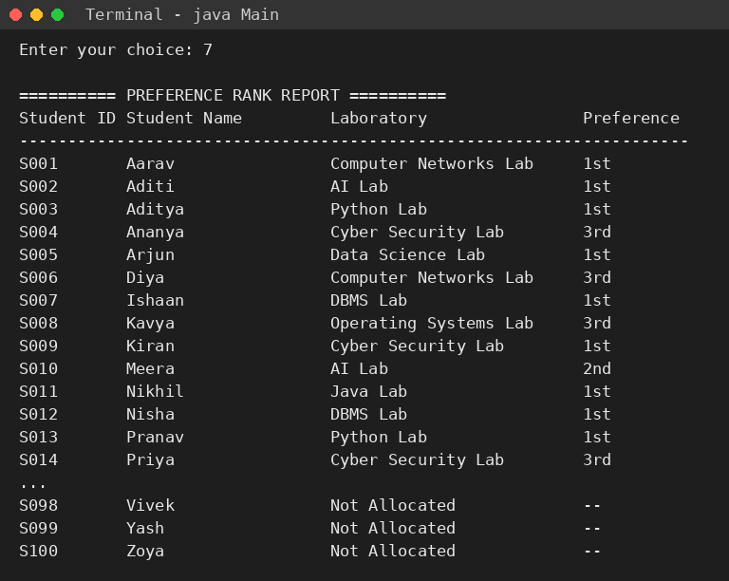
Figure 7: Preference rank report (option 7)
For each allocated student the report shows whether the assigned laboratory was his or her 1st, 2nd, 3rd, 4th or 5th preference.
7.2 Summary of results
Laboratory | Allocated | Capacity
AI Lab | 10 | 10
DBMS Lab | 8 | 8
Java Lab | 10 | 10
Python Lab | 9 | 9
Computer Networks Lab | 8 | 8
Operating Systems Lab | 9 | 9
Data Science Lab | 8 | 8
Cyber Security Lab | 8 | 8
Total | 70 | 70

Table 1: Laboratory-wise allocation
Preference rank received | Students | Share of allocated (70)
1st choice | 48 | 68.57%
2nd choice | 11 | 15.71%
3rd choice | 7 | 10.00%
4th choice | 2 | 2.86%
5th choice | 2 | 2.86%
Not allocated | 30 | —

Table 2: Distribution of preference ranks among allocated students
7.3 Discussion
Optimality of the matching. There are 100 students but only 70 seats, so no algorithm can allocate more than 70 students. The system reached this upper bound and filled all eight laboratories to capacity, which confirms that the maximum matching is working correctly (allocation rate 70.00%, seat utilisation 100%).
Quality with respect to preferences. Of the 70 allocated students, 48 (68.57%) received their first choice, 59 (84.29%) one of their top two choices and 66 (94.29%) one of their top three. The average rank received is about 1.56. This happens because seats are listed in preference order, so the depth-first search tries a student's most preferred laboratories first.
Who is left unallocated. Students S071–S100, the last 30 in the input file, are the unallocated ones. Kuhn's algorithm processes students in file order and an earlier student is only moved when that creates room for a later one; once all 70 seats are full no further augmenting path exists. The result is therefore dependent on input order, and this is a limitation of the current design.
Maximum size, not minimum preference cost. The algorithm guarantees the largest number of allocated students, but it does not minimise the total preference rank. A weighted approach (for example the Hungarian algorithm or a min-cost flow) could further improve satisfaction.
- CONCLUSION & FUTURE SCOPE
Conclusion
The project met its objectives. A student–laboratory allocation problem was modelled as a bipartite graph, with laboratory capacities expanded into seat vertices, and solved with Kuhn's maximum-matching algorithm in Java. The system reads its input from a CSV file, provides a menu-driven interface and generates allocation, laboratory-wise, preference-rank and summary reports. On the supplied dataset it allocated 70 of 100 students, which is the maximum possible with 70 seats, filled every laboratory to capacity, and gave 48 students their first choice and 59 students one of their top two choices. The project shows how a concept from the Data Structures and Algorithms-3 course – graph representation with augmenting-path search – can solve a practical administrative problem.
Future Scope
Near term
• Add input validation (for example for the menu choice and for malformed CSV rows) and read laboratory names and capacities from the file instead of fixing them in the code.
• Export the allocation, laboratory-wise and preference reports to CSV or PDF files, and provide a waiting list for the unallocated students.
Medium term
• Use weighted matching (Hungarian algorithm or min-cost max-flow) to minimise the total preference rank, or process students by priority (year, department or marks) to remove the dependence on input order.
• Replace Kuhn's algorithm with Hopcroft–Karp, which has a better worst-case running time for large datasets, and compare the two experimentally.
• Build a graphical or web front-end for students and administrators, with a database in place of the CSV file.
Long term
• Extend the model to timetable-aware allocation (lab slots, batches and faculty) and to multiple semesters.
• Add re-allocation when students change preferences or laboratory capacities change during the term.
- REFERENCES
[1] CP-Algorithms, “Kuhn's Algorithm for Maximum Bipartite Matching”. https://cp-algorithms.com/graph/kuhn_maximum_bipartite_matching.html
[2] GeeksforGeeks, “Maximum Bipartite Matching”. https://www.geeksforgeeks.org/?p=120260
[3] Educative, “What is the maximum bipartite matching problem?”. https://www.educative.io/answers/what-is-the-maximum-bipartite-matching-problem
[4] D. Sudak, “Applying matching algorithms to real allocation problems. Part 1”. https://denissudak.substack.com/p/applying-matching-algorithms-to-real
[5] University of British Columbia, CPSC 490 lecture notes, “Bipartite matching”. https://www.ugrad.cs.ubc.ca/~cs490/Spring06/notes/flow2.pdf
[6] University of Waterloo, CS 341 Algorithms, “Lecture 15 – Bipartite Matching”. https://cs.uwaterloo.ca/~lapchi/cs341-2021/notes/L15s.pdf
[7] Runestone Academy, Applied Combinatorics, “Section 14.2 Matchings in Bipartite Graphs”. https://runestone.academy/ns/books/published/appcomb/s_flowapplications_bip-match.html
[8] Pennsylvania State University notes, “Bipartite Matching & the Hungarian Method”. https://personal.science.psu.edu/lxv1/Matching.pdf
[9] F. Kuhn, Algorithm Theory, Chapter 6 – Maximum Matching, University of Freiburg. https://ac.informatik.uni-freiburg.de/teaching/ws24_25/algo_theo/slides/06_GraphAlgorithms3.pdf
[10] T. H. Cormen, C. E. Leiserson, R. L. Rivest and C. Stein, Introduction to Algorithms, MIT Press (chapter on maximum flow and bipartite matching).

